PROGRAM : 1
Create an app that displays your name and email id.

activity_main.xml
<?xml version="1.0" encoding="utf-8"?>
<LinearLayout xmlns:android="http://schemas.android.com/apk/res/android"
xmlns:app="http://schemas.android.com/apk/res-auto"
xmlns:tools="http://schemas.android.com/tools"
android:id="@+id/main"
android:layout_width="match_parent"
android:layout_height="match_parent"
android:background="#5900BCD4"
android:orientation="vertical"
tools:context=".MainActivity">

<TextView
android:id="@+id/tvName"
android:layout_width="match_parent"
android:layout_height="82dp"
android:layout_marginTop="30dp"
android:lineSpacingExtra="24sp"
android:text="Name"
android:textAlignment="center"
android:textSize="24sp"
android:textStyle="bold" />

<TextView
android:id="@+id/tvEmail"
android:layout_width="match_parent"
android:layout_height="71dp"
android:lineSpacingExtra="24sp"
android:text="Email"
android:textAlignment="center"
android:textSize="24sp"
android:textStyle="bold" />

</LinearLayout>

MainActivity.java
package com.example.p1_name_email;

import android.os.Bundle;

import androidx.activity.EdgeToEdge;
import androidx.appcompat.app.AppCompatActivity;
import androidx.core.graphics.Insets;
import androidx.core.view.ViewCompat;
import androidx.core.view.WindowInsetsCompat;

//import
import android.widget.TextView;

public class MainActivity extends AppCompatActivity {

@Override
protected void onCreate(Bundle savedInstanceState) {
super.onCreate(savedInstanceState);
EdgeToEdge.enable(this);
setContentView(R.layout.activity_main);

//Step 1 : Inintializing Textview
TextView tvname = findViewById(R.id.tvName);
TextView tvemail = findViewById(R.id.tvEmail);

//Step 2 : Replacing textviews with name and email
tvname.setText("Anshad");
tvemail.setText("marshu817@gmail.com");

ViewCompat.setOnApplyWindowInsetsListener(findViewById(R.id.main), (v, insets) -> {
Insets systemBars = insets.getInsets(WindowInsetsCompat.Type.systemBars());
v.setPadding(systemBars.left, systemBars.top, systemBars.right, systemBars.bottom);
return insets;
});
}
}

OUTPUT
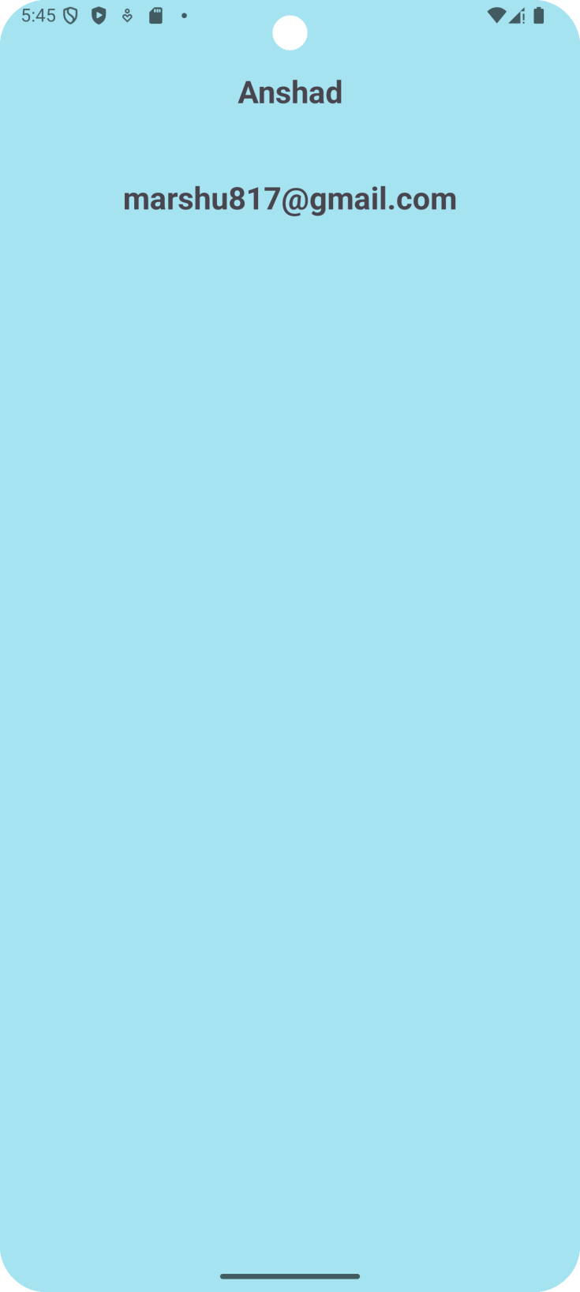

PROGRAM : 2
Create an app that takes marks of any three subjects from the user and
displays its sum and average.

activity_main.xml
<?xml version="1.0" encoding="utf-8"?>
<LinearLayout xmlns:android="http://schemas.android.com/apk/res/android"
xmlns:app="http://schemas.android.com/apk/res-auto"
xmlns:tools="http://schemas.android.com/tools"
android:id="@+id/main"
android:layout_width="match_parent"
android:layout_height="match_parent"
android:background="#5900BCD4"
android:orientation="vertical"
tools:context=".MainActivity">

<TextView
android:id="@+id/tvName"
android:layout_width="match_parent"
android:layout_height="82dp"
android:layout_marginTop="30dp"
android:lineSpacingExtra="24sp"
android:text="Name"
android:textAlignment="center"
android:textSize="24sp"
android:textStyle="bold" />

<TextView
android:id="@+id/tvEmail"
android:layout_width="match_parent"
android:layout_height="71dp"
android:lineSpacingExtra="24sp"
android:text="Email"
android:textAlignment="center"
android:textSize="24sp"
android:textStyle="bold" />

</LinearLayout>

